Press release 7 February 2022
The CRISP Website: a new collection of inspiring European heritage projects undertaken during the Covid-19 pandemic

Six European heritage partners are proud to present the CRISP website: a collection of heritage best practices developed during the COVID-19 pandemic. CRISP (Creative Research on Innovative and Sustainable Practices to get adults back in contact with heritage) is an EU funded project. Partners from five European countries have selected and described 61 pioneering heritage projects for the benefit of heritage institutions, stakeholders, and enthusiasts. With this compilation of (socially) innovative heritage cases, we aim to enrich existing heritage programming, inspire new ones and strengthening networks within and outside of the heritage field.
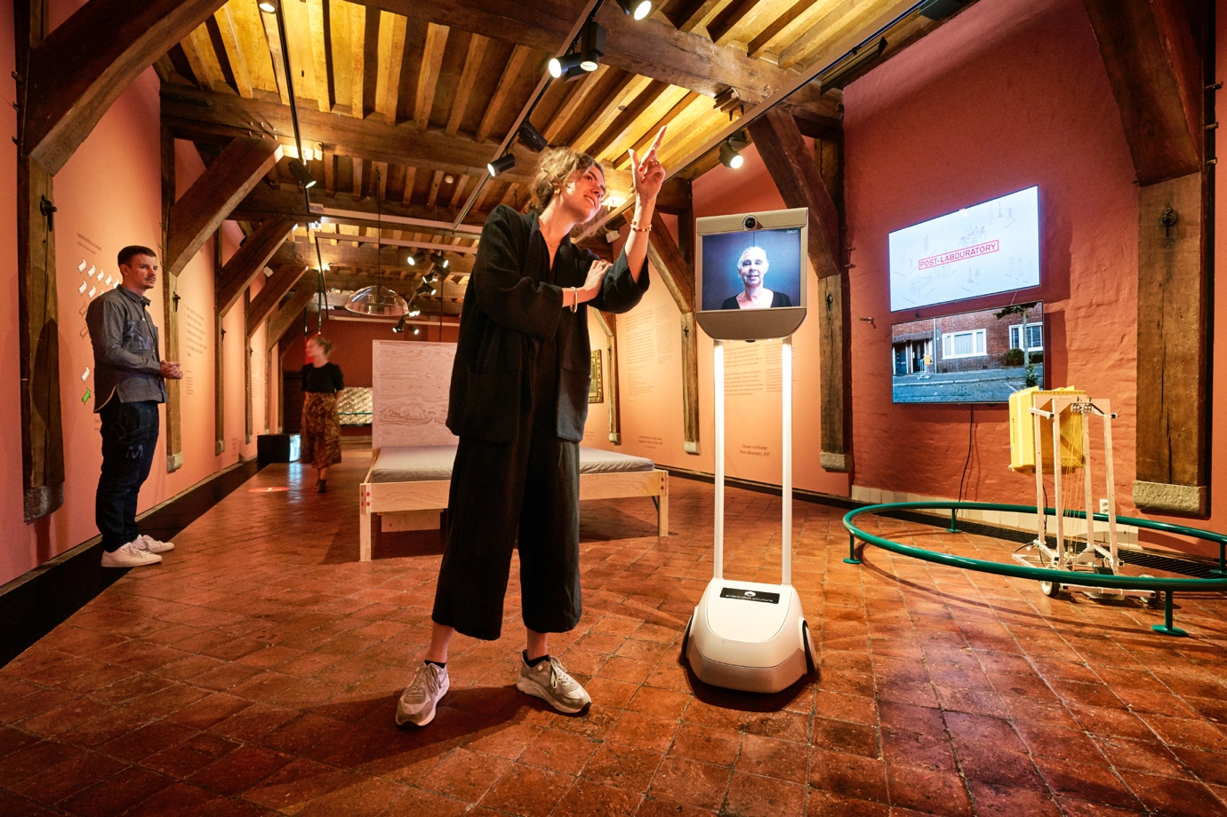
Photo: Marcel Kentin
The COVID pandemic hit hard on society, and it is no news that the heritage field also took a blow – especially during the lockdown phases. At the same time, this has been a time of creativity in the sector. Many institutions rapidly developed innovative programming for working around restrictions and isolation, connecting with audiences and partners in new ways. To make sure these ideas and innovations are not lost, we brought a selection of them together on a website: https://crisp-project.eu.
On the CRISP website, structured descriptions of inspiring heritage projects yield a great deal of practical information. Each case description not only portrays the project itself, but also looks into the background of each institution we spoke to. It furthermore reports on collaborations, costs and impact of the project. In each description, you will also find a brief interpretation of the project, as well as further references. You can browse the cases, freely search all the texts on the website, or use predefined tags and categories. All projects are also shown on a map.
In conclusion to our project, we want to emphasize how many heritage organizations such as (small) museums, archives, festivals and libraries rose above themselves during the pandemic. We saw great creativity, empathy and energy, and a renewed sensitivity to audiences' real needs. These organizations have been developing new skills, not only in the area of digitization and the use of new media, but also in more personal ways, developing new skills and initiating new collaborations.

We thank everyone who provided us with the details of their work, and also, we wish to thank the European Union for supporting this project in the form of an Erasmus Plus grant.
Take a look at the CRISP website now at: https://crisp-project.eu and feel free to contact us via: https://crisp-project.eu/contact
The CRISP Team:
EduVita (Italy)
Greek Cultural Institute (Greece)
VisMedNet (Malta)
Plungė Public library (Lithuania)
Quiosq Heritage Projects (The Netherlands)
Hogeschool Inholland, New Urban Tourism (The Netherlands)
===
Not for public dissemination

For further details regarding the CRISP project, please contact Bob Crezee (Quiosq Heritage Projects); email: bob.crezee@quiosq.eu, telephone no. +31 6 28 34 29 88‬. ‬‬‬‬‬‬

